Executes the Ansible - Playbook and checks if role nginx :

1. Go to Ansible Controller

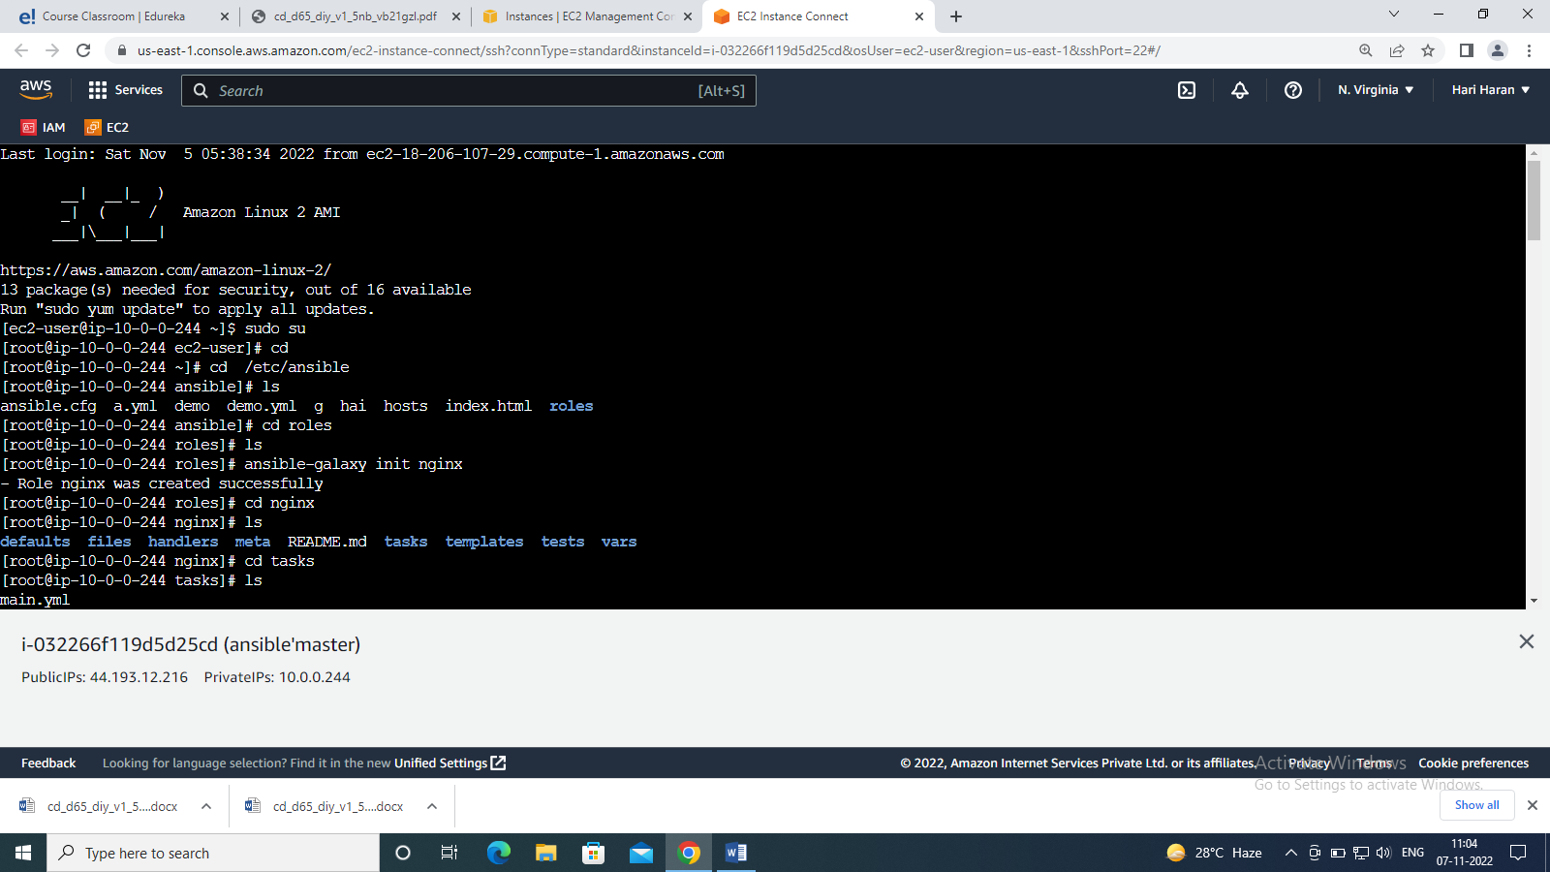

1. Go to /etc/ansible directory.

Cmd : cd /etc/ansible

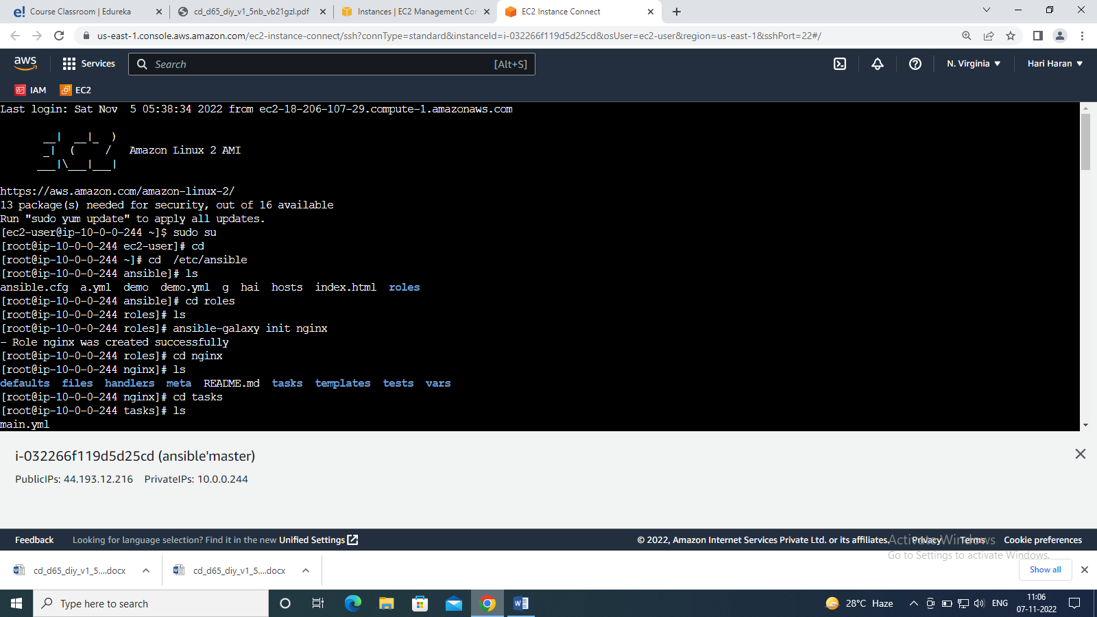

1. Go to the Roles directory.

Cmd: cd roles

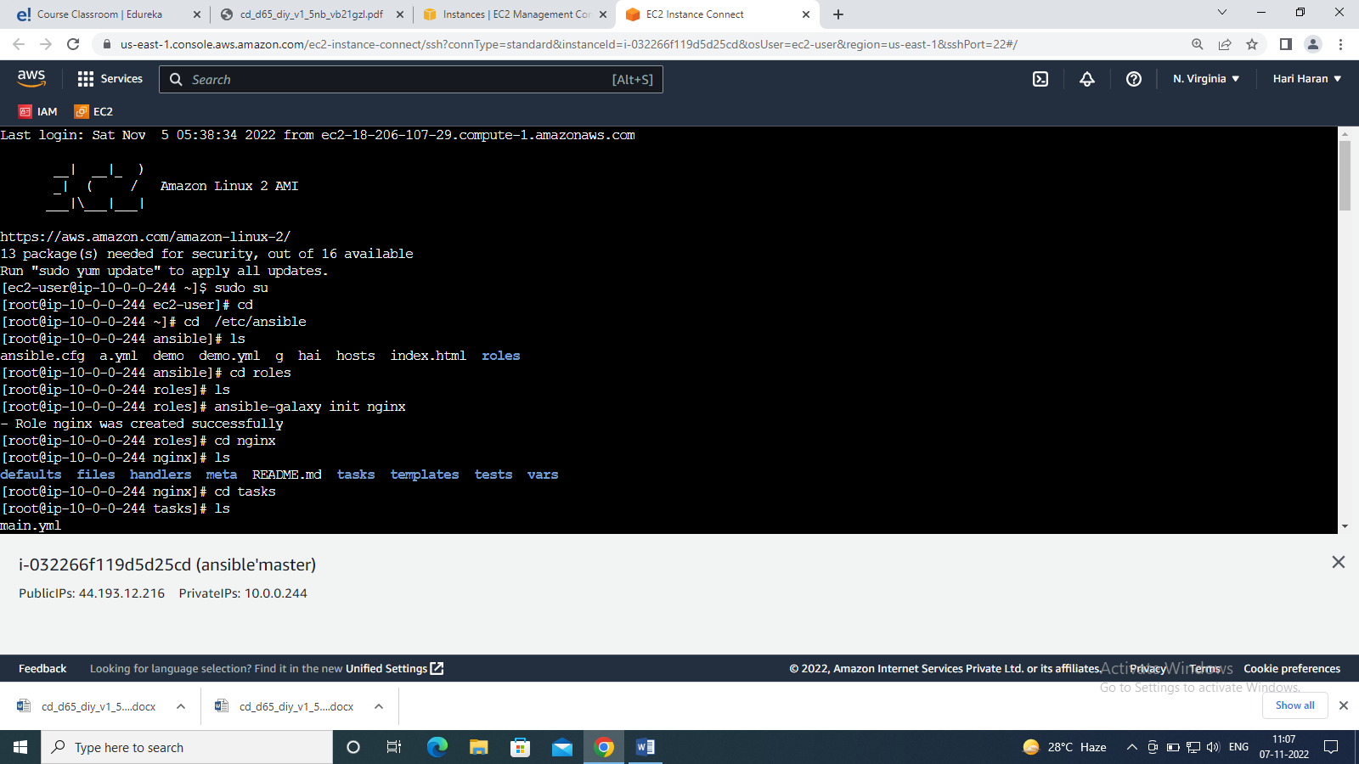

1. Execute the ansible-galaxy command to create a role – nginx.

Cmd : ansible-galaxy init nginx

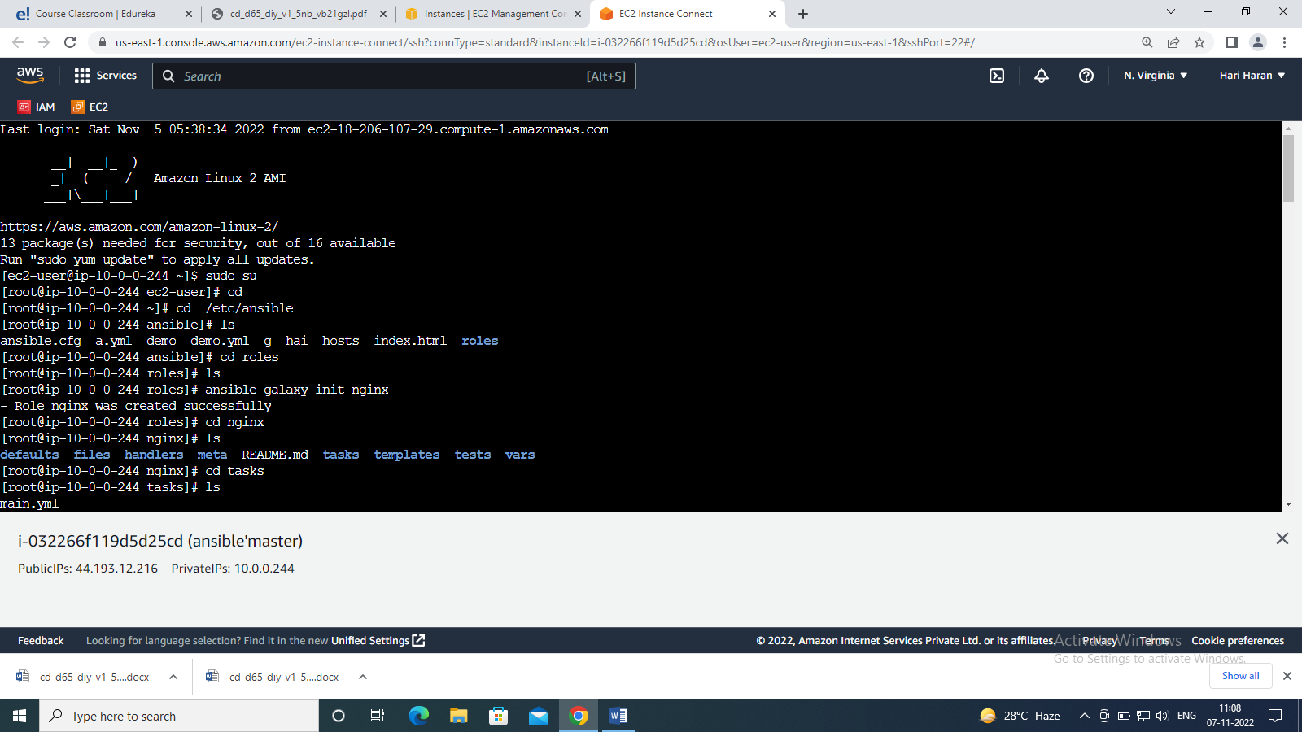

1. Add tasks in the task directory of the role to install nginx.
2. Add a task to start the nginx service.

Cmd : ---

# tasks file for nginx

- name: install nginx

apt: name=nginx state=present

- name: start nginx service

service: name=nginx state=started

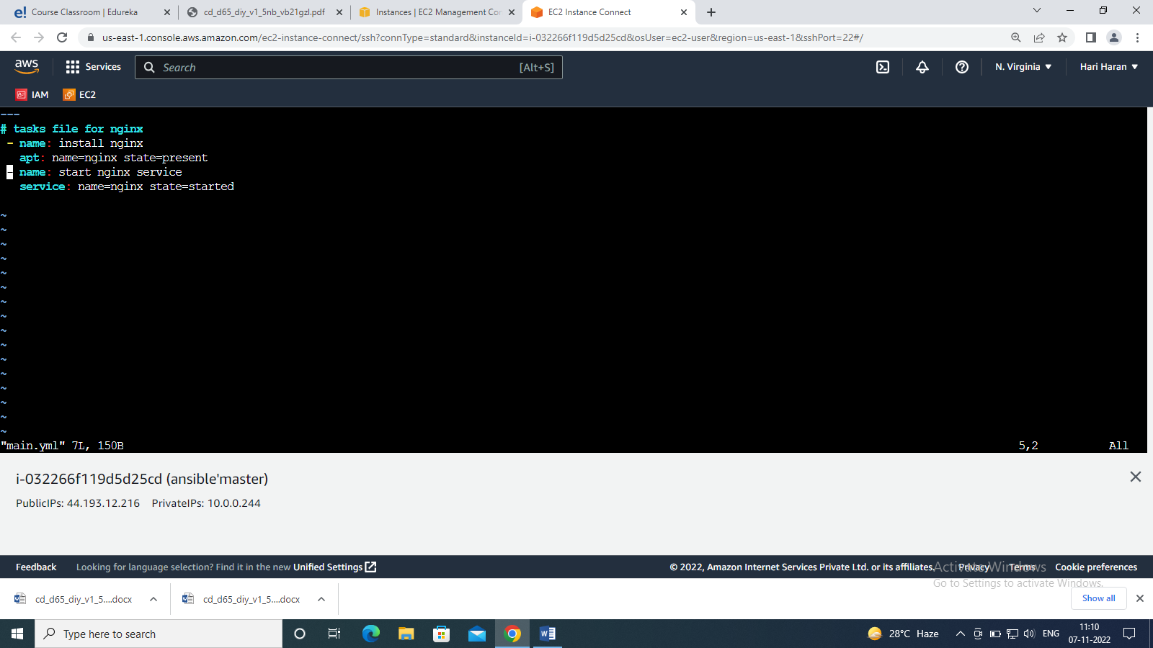

1. Write a new playbook – write-host details, become user details and call the role nginx.

Cmd: ---

- hosts: all

become: true

become_user: root

roles:

- nginx

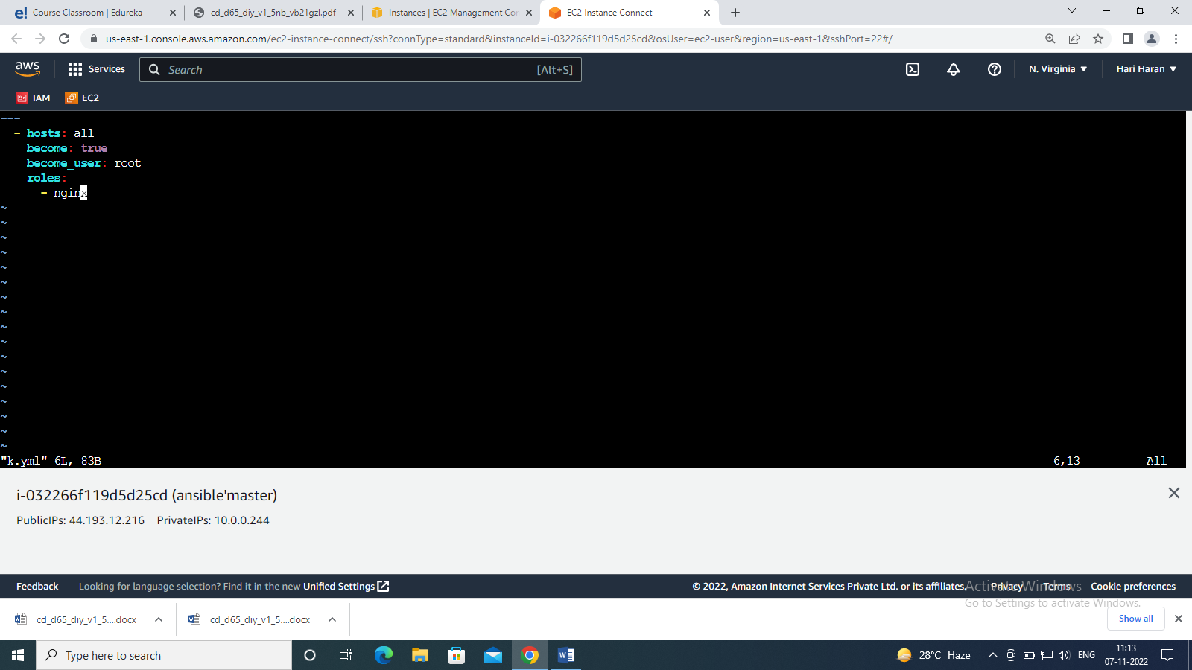

1. Execute the playbook and check if role nginx has been executed or not.

Cmd : ansible-playbook <playbook name>.yml

